**Skyline High School TSA**

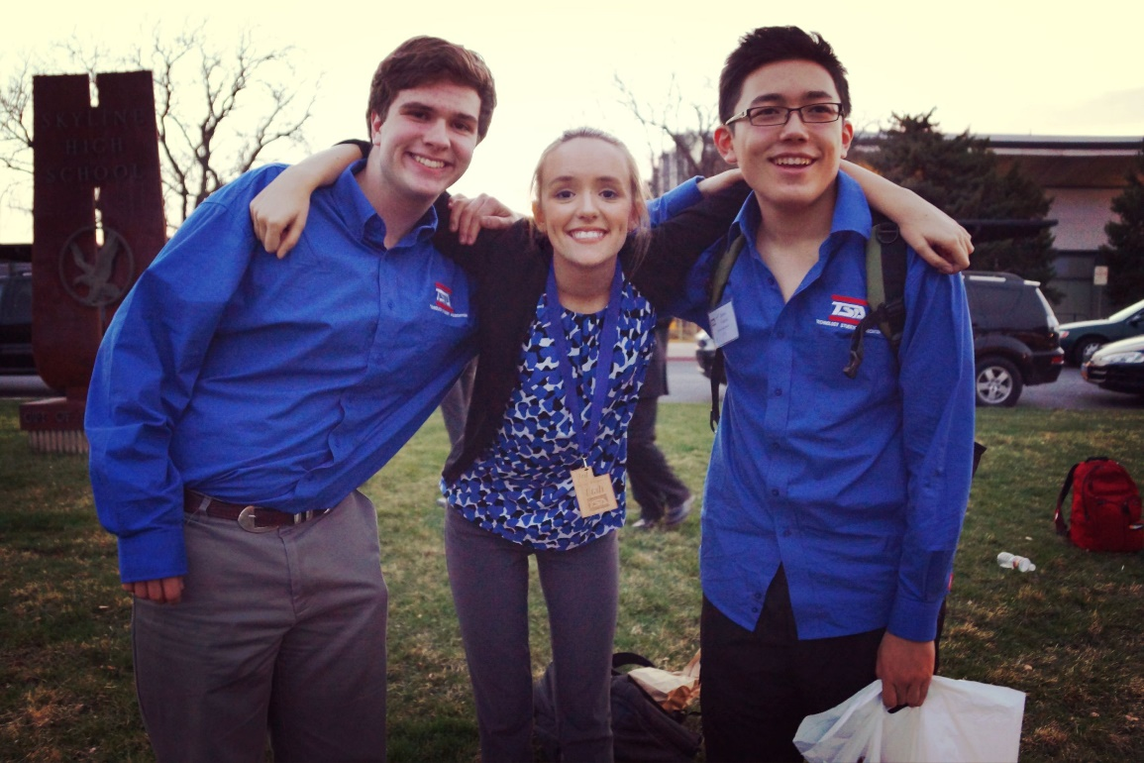

**What is TSA?**

The Technology Student Association (TSA) is a national student organization devoted exclusively to the needs of students who are engaged in science, technology, engineering and mathematics (STEM).

**Mission Statement**

THE MISSION OF SKYLINE TSA IS TO FULFILL THE PURPOSE OF NATIONAL TSA AND PROMOTE THE IDEAS AND STANDARDS OF THE TSA CREED, MOTTO AND MISSION STATEMENT AMONG THE MEMBERS OF SKYLINE TSA AND THE STUDENT BASE AT SKYLINE IN GENERAL

**Competitions**

In order to engage students with the drive to make a difference in the world, TSA offers activities that captivate and intrigue students into spending hours working on it after school for weeks at a time. TSA members have the opportunity to compete at exciting state conferences and then the annual National Conference. These competitions focus on the subjects of science, technology, engineering and math, however can vary greatly to suit the interests of the member. Students can work individually or as a team member in areas such as agriculture and biotechnology, website design, dragster design, flight challenge, film technology, CAD with 3D modeling, desktop publishing, debate, fashion design, radio controlled transportation, or scientific visualization.

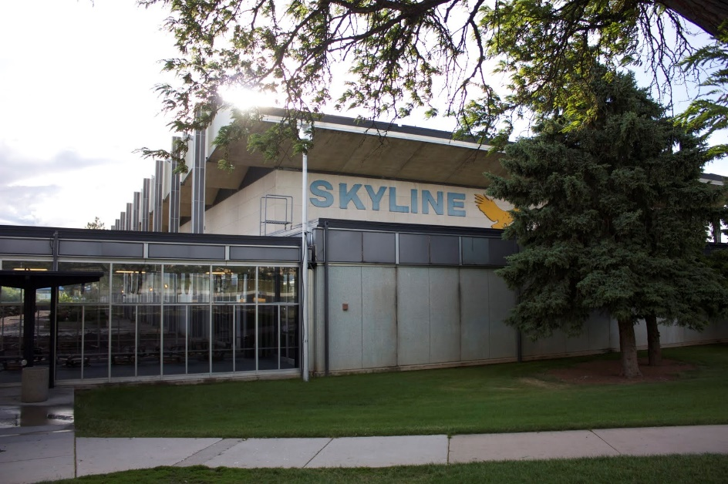

**School Chapters**

TSA chapters take the study of STEM beyond the classroom and allows students the chance to pursue their interests among friends with similar goals and interests. Together, chapter members work on competitive events, attend conferences on the state and national levels and have a good time raising funds to get there. Chapter organization develops leadership, as members may become officers within their state and then run nationally. Our chapters are committed to a national service project and are among the most service-oriented groups in the community.

**Leadership**



Alexei Garcia

Lydia Duan

Jeffrey Worley

Preston Richey



Joshua Norman

Colin Shen

Bernard Li

Emi Radetich